Healthcare Insurance Cost Dashboard (Power BI)
Project Overview
This project presents an interactive dashboard built using Power BI to analyze healthcare insurance data. The goal was to identify key factors influencing insurance charges and highlight high-risk customer segments.

Objectives
- Analyze how factors like smoking, BMI, age, and region affect insurance costs
- Identify high-risk customers based on health and lifestyle conditions
- Build a clean and interactive dashboard for data-driven decision making

Dataset
- Source: Insurance dataset (CSV file)
- Total Records: 1,338
- Features:
  - Age
  - Sex
  - BMI
  - Number of Children
  - Smoker Status
  - Region
  - Charges

Data Preparation (DAX Calculated Columns)
To enhance analysis, the following columns were created:
🔹 BMI Category
Categorized BMI values into:
- Underweight
- Normal
- Overweight
- Obese
🔹 Age Band
Grouped ages into:
- 18–25
- 26–35
- 36–45
- 46–55
- 56–65
- 66+
🔹 High Risk Flag
Defined high-risk customers as:
- Smoker AND Obese
- Values: 1 (High Risk), 0 (Not High Risk)

Measures Created (DAX)
- Total Customers = COUNTROWS(insurance)
- Average Charges = AVERAGE(insurance[charges])
- Median Charges = MEDIAN(insurance[charges])
- Smoker % = % of customers who smoke
- High Risk % = % of high-risk customers

Dashboard Features
KPI Section
- Total Customers
- Average Charges
- Median Charges
- Smoker Percentage
- High Risk Percentage

Visualizations
- Avg Charges by Smoker
  - Shows strong cost difference between smokers and non-smokers
- Avg Charges by BMI Category
  - Highlights higher costs for obese individuals
- Avg Charges by Age Band
  - Displays increasing trend with age
- Avg Charges by Region
  - Shows regional variations
- Scatter Plot (BMI vs Charges)
  - Demonstrates relationship between BMI and insurance cost
  - Highlights clustering of smokers at higher charge levels

Interactivity
Slicers were added for dynamic filtering:
- Region
- Sex
- Smoker
- Age Band
- BMI Category
This allows users to explore the data interactively and customize insights.

Dashboard Design
- Structured layout:
  - Top → KPI cards
  - Middle → Key comparisons
  - Bottom → Detailed insights
  - Right → Slicers
- Consistent color theme
- Clear titles and labels
- Clean and user-friendly interface

Key Insights
- Smokers incur significantly higher insurance charges compared to non-smokers
- Obese individuals tend to have higher medical costs
- Insurance charges increase with age
- High-risk customers (smoker + obese) form a small but critical segment
- Region has relatively minor impact on charges

Dashboard Preview
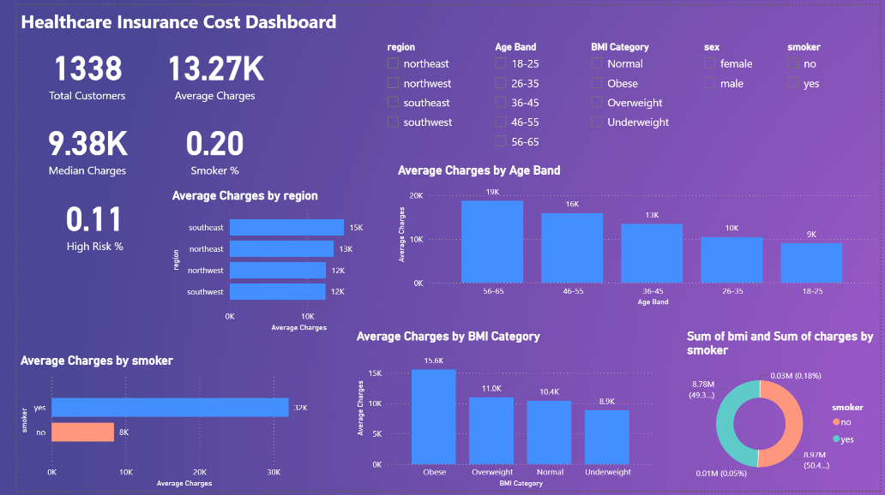

Tools Used
- Power BI
- DAX (Data Analysis Expressions)
- Data Visualization Techniques

👩‍💻 Author
Amrutha Thalla
📧 thallaamrutha5@gmail.com
🔗 LinkedIn: https://www.linkedin.com/in/amrutha-varshini-thalla-3688a23a2
🔗 GitHub: https://github.com/amruthathalla

